MP7 Test Plan
Heath Gerrald

To run my test plan driver use the flag -y. Run with no probing flags and keep the table size at 11.

To begin I filled up the table with basic insertions. Then I tested the following properties:
- Inserting items with the same key and verifying the data_ptr was updated through assertions.
- Deleting keys that were not in the table
- Deleting all of the keys and then trying to delete from the empty table

My program initially stores all keys as 0 until they have been inserted to. One value must stay empty at all times. To keep searches continuing after an entry has been deleted, entries that were previously taken are marked as 1’s. Deleting and retrieving ignores these 1’s, but inserts stop and insert at keys marked with 1 to increase execution time. When I run the program using double hashing, unless I use a prime number the program will not complete. A table size of 7 causes this issue. My program never crashes because I used while (i < 0) i+=table_size, instead of if.

Unit tests 1-4 are additional test drivers I created during the original debugging while still programming. These drivers can be access using -u (1:4).

To run my deletion driver use the -o flag. It will automatically make the table size 7 and use linear probing.

I also tested with valgrind to ensure there were no memory leaks.

My results from running part 3 listing under the Testing section of the MP7 pdf are shown below:
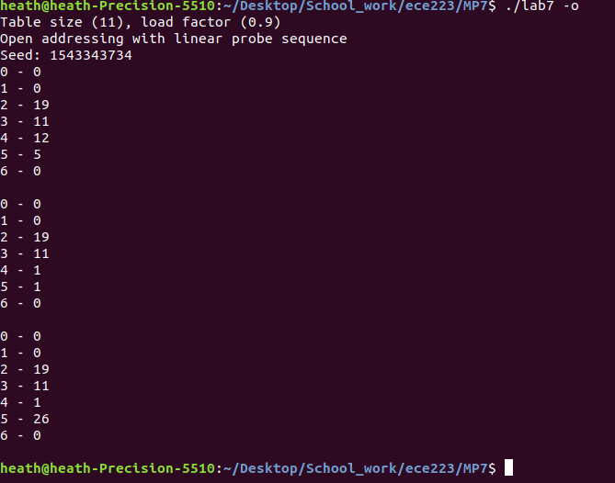
Part 3a
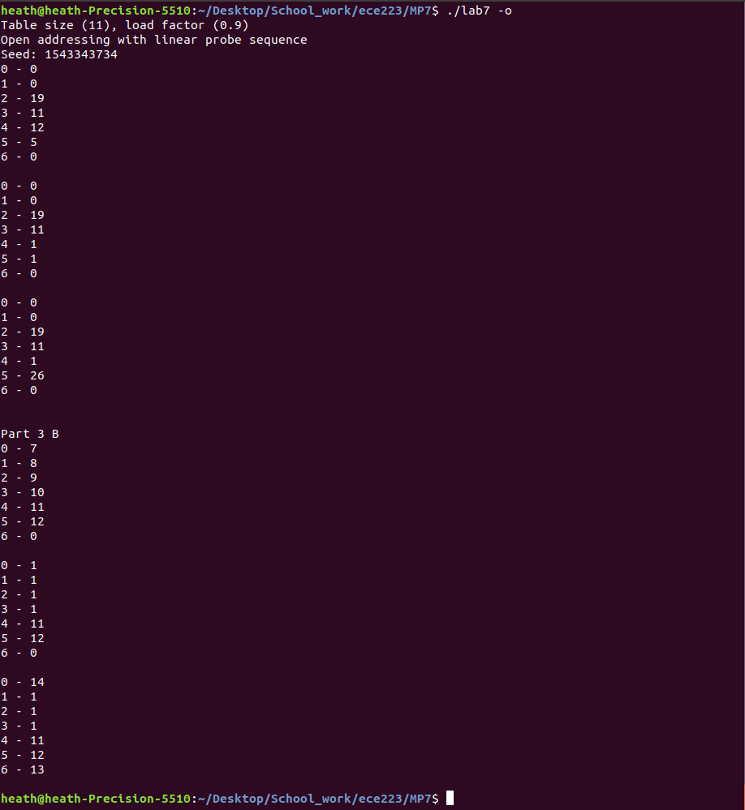
Part 3b

